8. BROADBAND SERVICE ELEMENT

In recognition of the importance of broadband infrastructure to the vitality of communities, the Georgia legislature passed the Achieving Connectivity Everywhere (ACE) Act (SB 402) in 2018. The Act provides broadband services planning, deployment, incentives, and other purposes. It also requires comprehensive plans to promote the deployment of broadband services. Coffee County and the Cities of Ambrose, Broxton, Douglas, and Nicholls recognize the importance of broadband expansion by including this Element in their Comprehensive Plan.
Percent Unserved Locations: 18%
Unserved Locations: 4,072
Served Locations: 18,740
Total Households: 14,438
Total Households with Internet: 9,616
Total Population: 43,092

Broadband services enable residents to access several vital services such as healthcare, economic opportunity, and education. Expansion of rural broadband and improvement in the position of broadband services can address concerns of resident out-migration. Effective and efficient broadband enables internet-based businesses to succeed in the global economy. Educating upcoming students in web literacy and digital skills training isn't easy without adequate broadband speed and connectivity.

The latest data shown in Map 1 below identifies 18% of the locations in Coffee County as unserved. However, it has been noted the technique of classifying unserved areas is too broad. A Census block is categorized as “served” if at least one consumer in a Census block has broadband service available to them. As more granular data becomes available, more accurate classification is expected, and the unserved percentage unserved is anticipated to rise.

County statistics are based on a fixed, terrestrial broadband definition of 25 megabits per second down and three megabits per second up. The broadband service is available to at least ONE consumer (residential and business) in a census block. Populated census blocks that did not meet this definition are delineated in Map 1 below as “Unserved.”

Map 1: Served & Unserved Areas in Coffee County and the Cities of Ambrose, Broxton, Douglas, and Nicholls
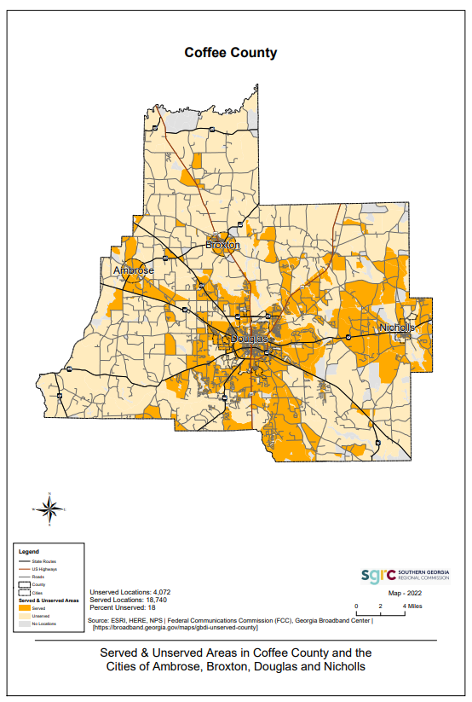
79.58% of households in Coffee County have a computer, compared to 88.6% of households statewide. Broadband internet subscriptions in the County are held by 66.60% of households. During the analysis of broadband services provision in Coffee County, an electronic poll was distributed to residences, businesses, hospitals, government bodies, libraries, and educational facilities. There were 178 responses received in total. 98.31% were residential, 2.25% were non-residential/Commercial, 0.56% were schools, 0.56% was the hospital/medical center, and 0.56% was a home office. Cable Modem had the highest percentage of internet access available at 64.07%, with Mobile/Wireless at 39.33%. 67.98% of responses indicated their internet service options are not adequate. 77.53% indicated that reliability does not sufficiently meet their needs. 73.60% indicated that the internet speed was not sufficient for their needs. The results of the broadband poll are included in the Appendix.

The average home in Coffee County can get up to 826 Mbps on their fiver internet plan. The fastest fiber download speed in the county is 1,000 Mbps, which is 78.71% available. Fiber is the fastest internet service for 9.86% of Coffee County homes. Cable is the fastest for 71.40% of the county, DSL is fastest for 16.6%, fixed wireless is most rapid for less than 1%, and satellite internet may be the only option for 2.58% of the Coffee County. Less than 1% of homes can only purchase 1.5 Mbps on the lower end. Approximately 87.98%, or 37,265 people, have Windstream DSL internet available in Coffee County.

There are seven internet service providers in Coffee County, covering 97.42% of the county. An average home gets up to 826 Mbps.

PROVIDER | COVERAGE IN COFFEE COUNTY | DATA SPEEDS
Windstream/DSL | 87.98% | 110 Mbps
Vyve Broadband/Cable | 78.54% | 1,000 Mbps
Windstream/Fiber | 9.31% | 833 Mbps
atc Broadband/Fiber | 1.72% | 100 Mbps
XFINITY (Comcast)/Cable | 1.72% | 931 Mbps
atc Broadband/DSL | 1.53% | 25 Mbps
Plant Telecommunications/DSL | 1.12% | 10 Mbps
DISH Satellite TV | 100% | N/A
DIRECTV Satellite TV | 100% | N/A
HughesNet Satellite Internet | 100% | 15Mbps

Map 2 below shows the internet coverage in Coffee County. Areas in green are more likely to have fiber, cable, DSL, or fixed wireless internet service. Windstream is the most widely available provider in Coffee County.

Map 2: Internet Coverage in Coffee County and the Cities of Ambrose, Broxton, Douglas, and Nicholls

Internet Availability Key

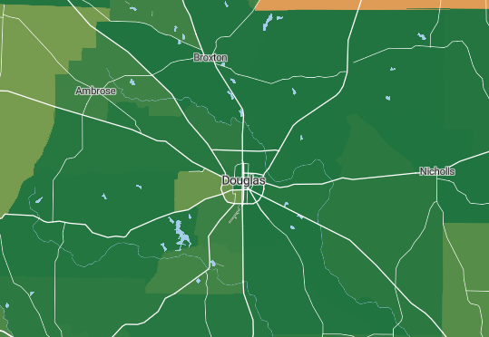

Cellular Service Availability in Coffee County

There are approximately 7,339 subscriptions of cellular data plans in Coffee County. Verizon, AT&T, and T-Mobile are the fastest cell service providers in Coffee County. Coffee County ranks #1296 out of 2182 counties for Georgia's fastest mobile internet network speeds. See Map 3 below:

Map 3: Cell Provider Area Locations

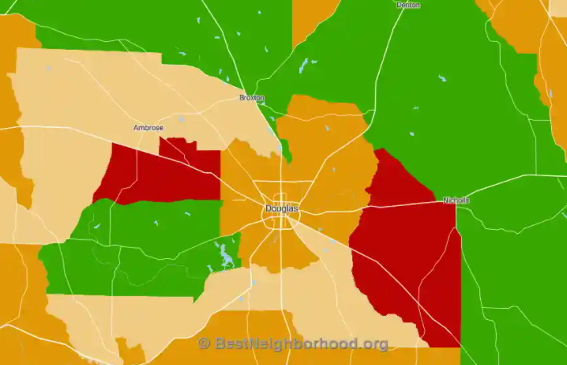

The southern portions of the county have better overall cellular coverage with faster data. The northwestern areas of Coffee County are generally slower. The mobile coverage may vary throughout the county based on the provider and location.

Coffee County and the Cities of Ambrose, Broxton, Douglas, and Nicholls recognize there are many barriers for private broadband services providers to effectively roll out necessary broadband infrastructure in rural areas of the State. City and county leaders recognize the importance of broadband quality for industry retention and recruitment within this community. Community leaders continuously seek to improve the quality of life for Coffee County/ Ambrose, Broxton, Douglas, and Nicholls residents. Industry relocation and business creation are dependent on the necessary infrastructure being in place. The lack of high-quality broadband infrastructure impedes recruitment and expansion of the established local industry. The Broadband Ready Community and site designation have been established to incentivize private investment in rural broadband services. The County and Cities plan to apply for these designations and signal to the State and private Internet Service Providers their prioritization of rural broadband improvement and expansion in their community.

II Plan Elements:
Goal 8: Broadband
Provide digital broadband and communications to ensure residents’ current and future needs, businesses, and industry within Coffee County and the Cities of Ambrose, Broxton, Douglas, and Nicholls.

2. ISSUES (NEEDS) AND OPPORTUNITIES
8. Broadband
Issues
8.1: Lack of sufficient digital broadband coverage in areas of Coffee County limits educational and economic development opportunities and causes communication problems for police, fire, and EMS.
8.2: More affordable, accessible, and higher-speed broadband access is needed throughout Coffee County and the Cities of Ambrose, Broxton, Douglas, and Nicholls.
8.3: Technological product development is outpacing the availability of broadband infrastructure, medical centers, schools, libraries, and businesses need to keep up with product developments yet are unable due to the limits of the infrastructure in rural areas.
Opportunities:
8.1: Better broadband services will improve the future for all citizens and businesses.
8.2: Encourage the partnership of providers to allow better broadband services.
8.3: Public/private partnerships could be developed to provide comprehensive broadband coverage that
is consistent, reliable, and equitable.
8.4: Broadband infrastructure may be included during road project development to increase project
efficiencies and outcomes.

5. Community Policies

Goal 8: Provide digital broadband and communications in a manner that ensures current and future needs of residents, businesses, and industry within Coffee County and the Cities of Ambrose, Broxton, Douglas, and Nicholls are met.
8.1: Lack of sufficient digital broadband coverage in large areas of Coffee County limits educational and
economic development opportunities and causes communication problems for police, fire, and EMS.

- Policy 7.1.1: More robust broadband services may enable more significant opportunities for
citizens and businesses.
- Policy 7.1.2: Include consideration of broadband infrastructure in roadway projects where the
necessary infrastructure may be included in the right-of-way.

7.2: More affordable, accessible, consistent, and higher-speed broadband access with additional bandwidth is needed throughout Coffee County and the Cities of Ambrose, Broxton, Douglas and Nicholls to serve residential, commercial, and industrial users.

- Policy 7.2.1: Public/Private Partnerships could be developed to provide comprehensive broadband
coverage that is consistent, reliable, and equitable.

7.3: Technological product development is outpacing the availability of broadband infrastructure,
medical centers, schools, libraries, and businesses need to keep up with product developments, yet
are unable due to the limits of the infrastructure in rural areas.

- Policy 7.3.1: The County and City should seek certification as Broadband Ready Communities and
support a more robust provision of broadband infrastructure.

6. Community Work Program

Coffee County Community Work Program Update (2019 - 2023)

PROJECTS | ESTIMATED COST | RESPONSIBLE PARTY | FUNDING SOURCES | GOAL | FY 19 | FY 20 | FY 21 | FY 22 | FY 23
LAND USE
Continue Enforcement of Codes | Staff Time | Coffee County | General Fund | 1c, 1d | x | x | x | x | x
TRANSPORTATION
Develop and implement a 6-Year Capital Improvement Plan for roads and other infrastructure | $6,200,000 | Coffee County | General Funds/SPLOST/GDOT/ TSPLOST (if passed) | 2a, 2b, 2c | x | x | x | x | x
Widen SR 32 @ CR 296 to west city limits of Douglas | $9,300,000 | Coffee County | GDOT/Coffee County Road Dept./City of Douglas | 2a, 2b, 2c | x | x
Pave streets in Oak Park, Phase II | $1,410,000 | Coffee County | SPLOST, CDBG | 2a, 2b, 2c | x | x
Pave streets in Oak Park, Phase III | $1,750,000 | Coffee County | SPLOST, CDBG | 2a, 2b, 2c |  | x | x | x
Pave streets/roads and implement drainage improvements | $500,000 | Coffee County | CDBG | 2a, 2b, 2c | x | x | x | x | x
Improve shoulder, complete and  pave Bud Hutchinson/Chaney  Road | $3,000,000 | Coffee County | LMIG/SPLOST/General Funds | 2a, 2b, 2c | x | x | x | x | x
ECONOMIC DEVELOPMENT
Continue development of infrastructure for Coffee County/Douglas Industrial Park | $250,000 | County/Industrial Authority | SPLOST/One Georgia | 3a, 3c | x | x | x | x | x
Continue financial support of Douglas/Coffee County Industrial Authority. | $400,000 | Coffee County | Set millage rate | 3a, 3c | x | x | x | x | x
HOUSING
Continue implementation of Oak Park Redevelopment Plan, including neighborhood revitalization | $1,500,000 | Coffee County | CDBG/General Funds | 4a | x | x | x
COMMUNITY FACILITIES & SERVICES
Renovate Health Department | $498,925 | Coffee County | CDBG | 6a, 6b | x | x | x | x | x
Renovate Farm Services (Ag)  Building | $300,000 | Coffee County | General Funds/SPLOST | 6a, 6b | x | x | x | x | x
Renovate Courthouse | $3,500,000 | Coffee County | General Funds | 6a, 6b | x
Purchase 30 Sheriff’s Vehicles | $1,200,000 | Coffee County | SPLOST, Grants | 6a, 6b | x | x | x | x | x
Purchase 2 Fire Trucks | $500,000 | Coffee County | SPLOST, Grants | 6a, 6b | x |  |  |  | x
Implement technology Improvements, to include replacing computer software & hardware | $950,000 | Coffee County | SPLOST, Grants | 6a, 6b | x | x | x
Purchase Public Safety Software | $300,000 | Coffee County, City of Douglas, 911 | SPLOST, Grants | 6a, 6b | x | x
Implement Fire ISO Rating  Contract | $28,000 | Coffee County | General Funds /Insurance Premium Tax Fund | 6a, 6b | x
Continue to update fire equipment | $400,000 | Coffee County | Fire Grants/SPLOST | 6a, 6b | x | x | x | x | x
Install Electronic Water Meters | $140,000 | Coffee County | SPLOST | 6a, 6b | x
INTERGOVERNMENTAL COORDINATION
Create new recreation complex at Old Fairground Property (Phase 1) | $3,000,000 | Coffee County, City of Douglas, Board of Education | SPLOST | 7a, 6a, 6b | x | x | x | x | x

BROADBAND
Provide adequate high-speed broadband access for local industries and commercial businesses. | $10,000,000 | County, Cities,  Public/Private  Partnership |  | General Fund, SPLOST, grants, private funding, |  | 6 |  |  |  |  |  |  |  | x |  | x

City of Ambrose Community Work Program Update (2019 - 2023)

PROJECTS | ESTIMATED COST | RESPONSIBLE PARTY |  | FUNDING SOURCE | GOAL |  | FY 19 | FY 20 | FY 21 | FY 22 | FY 23
TRANSPORTATION
Implement Downtown streetscape improvements | $500,000 | City of Ambrose |  | General Fund,  GDOT, Grants | 2a, 2b, 2c |  | x | x | x | x | x
Implement streetscape improvements continuing to the school | $200,000 | City of Ambrose |  | General Fund,  GDOT, Grants | 2a, 2b, 2c |  | x | x | x | x | x
Repave and mark City parking | $900 per space | City of Ambrose |  | General Fund | 2a, 2b, 2c |  | x | x | x
Lobby GDOT and legislators for  LMIG funding | Staff time | City of Ambrose/GDOT |  | General Fund | 2a, 2b, 2c |  | x | x | x | x | x
HOUSING
Increase quality rental housing stock through elimination of blighted property and by working to adopt and enforce City Code that will require rental property to be maintained by landlords | Staff time | City of Ambrose/Private entities |  | General Fund | 4a |  | x | x | x | x | x
Establish need for CHIP program | Staff time | City of Ambrose |  | General Fund | 4a |  | x | x | x | x | x
Utilize CHIP program to renovate homes | $200,000 | City of Ambrose |  | Grants | 4a |  | x | x | x | x | x
COMMUNITY FACILITIES & SERVICES
Purchase one backhoe for public utility department | $55,000 | City of Ambrose |  | SPLOST/  General Fund | 6a, 6b |  | x | x | x | x | x
Conduct water system upgrades, including refurbishing water tank | $400,000 | City of Ambrose |  | SPLOST, CDBG | 6a, 6b |  | x | x | x | x | x
Complete feasibility study to redevelop the old elementary school as City Hall/ Community Service Center | $50,000 | City of Ambrose |  | General Fund | 6a, 6b |  | x | x | x | x
Implement park improvements, to include resurfacing the walking trail and installing playground equipment | $50,000 | City of Ambrose |  | SPLOST | 6a, 6b |  | x | x | x | x | x
Purchase Fire Department  Equipment | $10,000 | City of Ambrose |  | SPLOST, Grants | 6a, 6b |  | x | x | x | x | x
BROADBAND
Provide adequate high-speed broadband access for local industries and commercial businesses. | $10,000,000 | County, Cities,  Public/Private  Partnership |  | General Fund, SPLOST, grants, private funding, | 6 |  |  |  |  | x |  |  | x

City of Broxton Community Work Program Update (2019 - 2023)
PROJECTS |  | ESTIMATED COST |  |  | RESPONSIBLE PARTY |  | FUNDING SOURCE |  | GOAL | FY 19 |  |  | FY 20 |  |  | FY 21 |  |  | FY 22 |  |  | FY 23 |  | LONG  TERM
LAND USE
Adopt design standards for property owners along US 441 |  | $20,000 |  |  | City of Broxton |  | General Fund and DCA Grant |  | 1b | x |  |  | x
TRANSPORTATION
Implement shoulder improvements to US 441 |  | $500,000 |  |  | City of Broxton |  | GDOT |  | 2a, 2b, 2c |  |  |  | x |  |  | x |  |  | x
Lobby GDOT and legislators for LMIG funding |  | Staff time |  |  | City of Broxton |  | General Fund |  | 2a, 2b, 2c | x |  |  | x |  |  | x |  |  | x |  |  | x
Implement streetscape enhancements in downtown |  | $600,000 |  |  | City of Broxton |  | GDOT TE |  | 2a, 2b, 2c | x |  |  | x |  |  | x |  |  | x
ECONOMIC DEVELOPMENT
Create a targeted business plan |  | $25,000 |  |  | City of Broxton |  | Private funds |  | 3b, 3c | x |  |  | x
Conduct a study for potential of industrial site in city |  | $25,000 |  |  | City of Broxton |  | General fund |  | 3a | x |  |  | x
HOUSING
Eliminate blighted areas throughout the city through an agreement with the County to use their Code Enforcement Officer for identifying and enforcing condemnation of dilapidated properties |  | Staff time |  |  | City of Broxton |  | General Fund |  | 4a | x |  |  | x
COMMUNITY FACILITIES & SERVICES
Repair and replace aging infrastructure, such as water and sewer lines |  | $500,000 |  |  | City of Broxton |  | CDBG grants/SPLOST |  | 6a, 6b | x |  |  | x |  |  | x |  |  | x |  |  | x |  | x
BROADBAND
Provide adequate high-speed broadband access for local industries and commercial businesses. | $10,000,000 |  |  | County, Cities,  Public/Private  Partnership |  |  |  | General Fund, SPLOST, grants, private funding, | 6 |  |  |  |  |  |  |  |  |  |  | x |  |  | x

City of Douglas Community Work Program Update (2019 - 2023)

PROJECTS | ESTIMATED COST |  | RESPONSIBLE PARTY | FUNDING SOURCE |  | GOAL |  |  | FY 19 |  | FY 20 |  | FY 21 |  | FY 22 |  | FY 23
CULTURAL RESOURCES
Update Historic Preservation Guidelines | Staff time |  | City of Douglas /HPC | General Funds |  | 5b |  |  |  |  | x
Implement façade improvements to historic buildings | $500,000 |  | DDA/City of Douglas | Private Developers/DDA loan funds |  | 5a, 5b |  |  | x |  | x |  | x |  | x |  | x
ECONOMIC DEVELOPMENT
Complete Infrastructure of Satilla  Industrial Park | $3.8 Million |  | EDA | SPLOST/EDA |  | 3a, 3c, 3d |  |  | x |  | x |  | x |  | x
Encourage Retail/Commercial Development along 441/US 31 South, along SR 135 and other areas of city | Staff time |  | City of Douglas /Private Developers | Private Developers |  | 3a, 3b, 3c, 3d |  |  | x |  | x |  | x |  | x |  | x
Implement Downtown Streetscape Repairs, per the Downtown Master Plan | $80,000 |  | City of Douglas, DDA | SPLOST/  General Funds |  | 3b |  |  | x |  | x |  | x |  | x |  | x
HOUSING
Implement housing rehabilitation for low- and middle-income families | $612,000 |  | City of Douglas | CDBG, CHIP, General Funds |  | 4a |  |  | x |  | x |  | x |  | x
Facilitate development of Downtown Condos, Townhouses, Loft Apartments, and Mixed Use, per the Downtown Master Plan | Staff time |  | DDA, City of Douglas, Developers/ Property & Business Owners | Private/GMA/DCA |  | 4a |  |  |  |  |  |  |  |  | x
LAND USE
Facilitate infill development in Residential, commercial, and industrial Areas | Staff time |  | City of Douglas | Private |  | 1a |  |  | x |  | x |  | x |  | x |  | x
Enforce Property Maintenance and Building Codes | Staff time |  | City of Douglas | General Funds |  | 1b, 1d |  |  | x |  | x |  | x |  | x |  | x
TRANSPORTATION
Create Sidewalk Master Plan | $15,000 |  | City of Douglas | General Funds |  | 2a,b,c |  |  | x |  | x |  | x |  | x |  | x
Implement Sidewalk Master Plan  To Create Connectivity | $5,000,000 |  | City of Douglas | LMIG/SPLOST/City |  | 2a,b,c |  |  | x |  | x |  | x |  | x |  | x
Relieve School Related Traffic  Congestion | Staff time |  | City of Douglas /BOE/DOT | City/DOT |  | 2a,b,c |  |  | x |  | x |  | x |  | x |  | x
Upgrade street signs to meet GDOT sign reflectivity standards | $100,000 |  | City of Douglas | General Funds |  | 2a,b,c |  |  | x |  | x |  | x |  | x |  | x
Extend Greenway Trail to SR 206 | $125,000 |  | City of Douglas | SPLOST |  | 2a,b,c |  |  | x
Extend Greenway Trail from SR 206 to High School | $150,000 |  | City of Douglas | SPLOST |  | 2a,b,c |  |  |  |  |  |  |  |  | x |  | x
Widen SR 135 from US 441 to  SR 32 | $2,900,000 |  | City of Douglas | GDOT |  | 2a,b,c |  |  | x
Resurface and pave streets per priority list | $200,000/mile (resurfacing) $700,000/mile (new paving) |  | City of Douglas | SPLOST, LMIG, GDOT, Grants, General Fund |  | 2a,b,c |  |  | x |  | x |  | x |  | x |  | x
Implement LMIG Matching & Parking Lot Improvements (including Downtown lots) | $425,000 |  | City of Douglas | SPLOST/Gen Funds |  | 2a,b,c |  |  | x |  | x |  | x |  | x |  | x
LMIG Matching Cemetery Paving | $250,000 |  | City of Douglas | SPLOST/Gen Funds |  | 2a,b,c |  |  |  |  |  |  |  |  | x
COMMUNITY FACILITIES & SERVICES
Construct the final Gateway Sign on the South Entrance of town | $35,000 |  | City of Douglas | City/SPLOST |  | 6a, 6b |  |  | x |  | x
Install Digital Signs for Gateway  Signs | $100,000 |  | City of Douglas | General Funds |  | 6a, 6b |  |  | x |  | x |  | x |  | x |  | x
City Hall Renovation/Expansion | $2.1 Mill |  | City of Douglas | Grants, General Fund |  | 6a, 6b |  |  | x
Construct Cemetery Columbarium in Section R | $10,000 |  | City of Douglas | City |  | 6a, 6b |  |  | x |  | x
Construct Public Works Facility | $1,000,000 |  | City of Douglas | Grants, General Fund |  | 6a, 6b |  |  |  |  |  |  | x |  | x |  | x
Construct Purchasing Facility | $1,000,000 |  | City of Douglas | Grants, General Fund |  | 6a, 6b |  |  |  |  |  |  | x |  | x |  | x
Install Electric Reconductor lines on Madison from the Methodist Church to the City limits 441 North | $360,000 |  | City of Douglas | Rate Monies |  | 6a, 6b |  |  | x
Provide Spanish translation services for city services such as courts and police to adequately and effectively communicate with the growing Hispanic population | Staff time |  | City of Douglas | State and federal funds, grants, general funds |  | 6a, 6b |  |  | x |  | x |  | x |  | x |  | x
WWII Airbase Buildings  Renovation | $165,000 |  | City of Douglas | SPLOST/Grants |  | 6a, 6b |  |  | x |  | x |  | x |  | x |  | x
Water & Sewer
Construct Water/Wastewater  Facility | $1,000,000 |  | City of Douglas | Grants, General Fund |  | 6a, 6b |  |  |  |  |  |  | x |  | x |  | x
Create and implement Storm Drainage Master Plan | $400,000 |  | City of Douglas | SPLOST |  | 6a, 6b |  |  | x |  | x |  | x
Extend water, wastewater, and sewer lines, per master plan, including unincorporated areas where feasible | $1,000,000 |  | City of Douglas | SPLOST, Grants, General Fund |  | 6a, 6b |  |  | x |  | x |  | x |  | x |  | x
Implement CDBG Project for Daughtry, Cherry, Bryan St., and Phillips Sts. | $585,042 |  | City of Douglas | $460,597/CDBG  $120,403/City  $4,042/CD FUN |  | 6a, 6b |  |  | x |  | x
Install Bo Jo Ella Lift Station backup pump system | $150,000 |  | City of Douglas | Rate Monies |  | 6a, 6b |  |  | x
Install Water/Sewer lines and paving to Satilla Industrial Park | $1,000,000 |  | City of Douglas | Grants, General Fund |  | 6a, 6b |  |  | x |  | x |  | x |  | x |  | x
Rehab Water/Wastewater mains and Sewer Lift Stations | $225,000 |  | City of Douglas Water and Wastewater Dept. | SPLOST |  | 6a, 6b |  |  | x |  | x |  | x |  | x |  | x
Rehab/replace water, wastewater, and sewer lines and mains, per Master Plan | $5,000,000 |  | City of Douglas | SPLOST/Rate Monies/Grants |  | 6a, 6b |  |  | x |  | x |  | x |  | x |  | x
Replace Water/Sewer Infrastructure under roadways before paving | $2,000,000 |  | City of Douglas | SPLOST/Rate Monies |  | 6a, 6b |  |  | x |  | x |  | x |  | x |  | x
Wastewater Treatment Plant Back Lift Station Replacement | $1,200,000 |  | City of Douglas | SPLOST |  | 6a, 6b |  |  | x
Natural Gas
Construct lateral natural gas line to connect to new supply line being built between Mobile, AL and Savannah, GA | $3,100,00 |  | City Natural Gas Dept. | Enterprise funds |  | 6a, 6b |  |  | Long-term (2024 or later)
Extend Natural Gas Lines to serve agricultural customers and unincorporated areas | $60,000 per mile |  | City of Douglas | Rate Monies, Enterprise funds |  | 6a, 6b |  |  | x |  | x |  | x |  | x |  | x
Install Natural Gas Infrastructure to Satilla Industrial Park | $100,000 |  | City of Douglas | Rate Monies |  | 6a, 6b |  |  | x |  | x
Airport
Complete stage 2 of Airport Industrial Park | $1,523,000 |  | City & DCCEDA | SPLOST, One GA, EDA, DCCEDA |  | 6a, 6b |  |  | Long-term (2024 or after)
Construct Corporate Area Access Road Phase I | $120,000 |  | City of Douglas | FAA/GDOT/SPLOST |  | 6a, 6b |  |  |  |  |  |  |  |  | x
Construct north corporate hangar area at Airport; implement taxiway improvements Phase I | $330,000 |  | City of Douglas | FAA/SPLOST |  | 6a, 6b |  |  | x |  | x
Corporate Area Access Road at Airport, Phase I & Corporate Taxiway Improvements Design | $50,000 |  | City of Douglas | FAA/SPLOST |  | 6a, 6b |  |  |  |  |  |  | x
Corporate Aea Sitework at Airport Including Utilities Design/ Construction | $340,000 |  | City of Douglas | GDOT/City |  | 6a, 6b |  |  |  |  |  |  |  |  | x
Enclose Open Air T-Hangars at  Airport | $80,000 |  | City of Douglas | SPLOST |  | 6a, 6b |  |  |  |  | x
Implement taxiway improvements at Airport, Phase II | $383,000 |  | City of Douglas | FAA/SPLOST |  | 6a, 6b |  |  |  |  |  |  | x |  | x
Implement taxiway improvements at Airport, Phase III | $448,000 |  | City of Douglas | FAA/SPLOST |  | 6a, 6b |  |  |  |  |  |  |  |  |  |  | x
Install Security Fencing at Airport | $180,000 |  | City of Douglas | GDOT/City |  | 6a, 6b |  |  |  |  |  |  | x
Terminal Area North Apron Expansion at Airport | $350,000 |  | City of Douglas | FAA/GDOT/SPLOST |  | 6a, 6b |  |  |  |  |  |  |  |  |  |  | x
Fire Department
Purchase Engine Truck for Fire  Dept. | $450,000 |  | City of Douglas | SPLOST |  | 6a, 6b |  |  |  |  |  |  |  |  |  |  | x
Purchase Ladder Truck for Fire  Dept. | $700,000 |  | City of Douglas | SPLOST |  | 6a, 6b |  |  |  |  | x
Reduce fire ISO rating from 3 to 2 | $200,000 |  | Douglas Fire Dept. | City funds |  | 6a, 6b |  |  | x |  | x
Police Department
Increase drug prevention HEAT Program | Staff time |  | Douglas Police Department, Coffee County Sheriff Department | Gov’s Office of Highway Safety Grant |  | 6a, 6b |  |  | x
Purchase 16 Police  Vehicles w/Equipment | $800,000 |  | City of Douglas | Grants, General Fund |  | 6a, 6b |  |  | x |  | x |  |  |  | x |  | x
Purchase E-ticket printers for police | $8,000 |  | Douglas Police Department | Drug funds |  | 6a, 6b |  |  | x
Parks & Recreation
Apply for Arts Grant for Martin  Center | Staff time |  | City of Douglas | Georgia Council for the Arts |  | 6a, 6b |  |  | x |  | x |  | x
Caboose & Deck Restoration | $100,000 |  | City of Douglas /Private | City/Grant/Private Donations |  | 6a, 6b |  |  | x |  | x |  | x
Construct Event Facility | $2.4 Mill |  | City of Douglas | General Funds |  | 6a, 6b |  |  |  |  |  |  | x |  | x |  | x
Establish Dog Park | $100,000 |  | City of Douglas | General Funds/grants |  | 6a, 6b |  |  | x |  | x
Implement Madison Avenue Park Development, per Downtown Master Plan | $350,000 |  | City of Douglas /DDA | General Funds/Private |  | 6a, 6b |  |  | x |  | x |  | x |  | x |  | x
Make Improvements to Parks per Parks Master Plan | $1,000,000 |  | City of Douglas | SPLOST, State and federal funds, grants |  | 6a, 6b |  |  | x |  | x |  | x |  | x |  | x
Martin Center Sound, Lighting &  Equipment Upgrades | $150,000 |  | City of Douglas /Private | City/Grant/Private Donations |  | 6a, 6b |  |  |  |  | x |  | x |  | x
Miracle Field Construction | $648,736 |  | City of Douglas | SPLOST/DNR/Private |  | 6a, 6b |  |  | x
North Madison Park parking improvements & playground equipment at Alunza | $60,000/playground $950 per parking space |  | City of Douglas | SPLOST, State and federal funds, grants |  | 6a, 6b |  |  | x |  | x |  | x
Playground Structures for Parks | $50,000 |  | City of Douglas | SPLOST |  | 6a, 6b |  |  |  |  | x
Rehab the Davis Wade Swimming Pool, to include a New Pool House, Splash Pad, and Paving | $500,000 |  | City of Douglas | SPLOST |  | 6a, 6b |  |  |  |  | x
INTERGOVERNMENTAL COORDINATION
Implement E911 Upgrade | $280,000 |  | City/County | SPLOST |  | 7c |  |  | x
BROADBAND
Provide adequate high-speed broadband access for local industries and commercial businesses. | $10,000,000 |  | County, Cities,  Public/Private  Partnership |  | General Fund, SPLOST, grants, private funding, |  | 6 |  |  |  |  |  |  |  |  | x |  |  | x

City of Nicholls Community Work Program Update (2019 - 2023)

PROJECTS |  | ESTIMATED COST |  | RESPONSIBLE PARTY | FUNDING SOURCE | GOAL |  |  |  | FY 19 |  |  | FY 20 |  | FY 21 |  | FY 22 |  |  |  | FY 23
LAND USE
Develop nuisance abatement for rehabilitation |  | Staff Time |  | City of Nicholls /DCA | General Fund | 1b, 1d |  |  |  | x |  |  | x |  | x |  | x |  |  |  | x
Develop local zoning ordinance, including nuisance abatement for rehabilitation |  | $20,000 |  | City of Nicholls | General Fund | 1b, 1d |  |  |  | x |  |  | x |  | x |  | x |  |  |  | x
Develop public input procedures for  code violations |  | Staff time |  | City of Nicholls | General Fund | 1b, 1d |  |  |  | x |  |  | x |  | x |  | x
COMMUNITY FACILITIES & SERVICES
Develop a public outreach campaign for services and programs |  | Staff time |  | City of Nicholls | General Fund | 6a, 6b |  |  |  | x |  |  | x |  | x |  | x |  |  |  | x
Develop a community assessment of code enforcement issues |  | $5,000/ Staff time |  | City of Nicholls | General Fund | 6a, 6b |  |  |  | x |  |  | x |  | x |  | x |  |  |  | x
Addition to Community Center |  | $150,000 |  | City of Nicholls | SPLOST | 6a, 6b |  |  |  | x |  |  | x |  | x |  | x |  |  |  | x
Renovations to City Hall |  | $250,000 |  | City of Nicholls | SPLOST | 6a, 6b |  |  |  | x |  |  | x |  | x |  | x |  |  |  | x
Upgrades to Treatment Plant and replace Lift Station pumps |  | $500,000-  $750,000 |  | City of Nicholls | CDBG/SPLOST | 6a, 6b |  |  |  | x |  |  | x |  | x |  | x |  |  |  | x
Water tank improvements |  | $200,000 |  | City of Nicholls | SPLOST | 6a, 6b |  |  |  | x |  |  | x |  | x |  | x |  |  |  | x
Purchase public safety equipment; police cars and fire fighter equipment |  | $200,000 |  | City of Nicholls | SPLOST | 6a, 6b |  |  |  | x |  |  | x |  | x |  | x |  |  |  | x
City park improvements/City Youth  Park |  | $250,000 |  | City of Nicholls | SPLOST | 6a, 6b |  |  |  | x |  |  | x |  | x |  | x |  |  |  | x
Construct combination basketball court and walking trails |  | $150,000 |  | City of Nicholls | SPLOST | 6a, 6b |  |  |  | x |  |  | x |  | x |  | x |  |  |  | X
ECONOMIC DEVELOPMENT
Identify appropriate locations for  new industrial sites |  | $500,000 |  | City of Nicholls | General Fund | 3a |  |  |  | x |  |  | x |  | x |  | x |  |  |  | x
TRANSPORTATION
Annual sidewalk repair |  | $100,000/year |  | City of Nicholls | General Fund/SPLOST | 2a, 2b, 2c |  |  |  | x |  |  | x |  | x |  | x |  |  |  | x
Resurface roads listed by priority  on LMIG list submitted to GDOT for  funding |  | $500,000 |  | City of Nicholls | SPLOST | 2a, 2b, 2c |  |  |  | x |  |  | x |  | x |  | x |  |  |  | x
Widen SR 32 |  | $9.3 million |  | GDOT | GDOT | 2a, 2b, 2c |  |  |  | Long-term (2024 or later)
Enhance SR 32 streetscaping in downtown Nicholls |  | $200,000 |  | GDOT, City of Nicholls, Grants | GDOT | 2a, 2b, 2c |  |  |  | Long-term (2024 or later)
BROADBAND
Provide adequate high-speed broadband access for local industries and commercial businesses. | $10,000,000 |  |  | County, Cities,  Public/Private  Partnership | General Fund, SPLOST, grants, private funding, |  | 6 |  |  |  |  |  |  |  |  |  |  | x |  | x

COMPREHENSIVE PLAN APPENDIX

Sign-In Sheets
Public Hearing Notices
Broadband Survey Results
Transmittal Letters

Broadband Survey Results

What type of use is located on this property?
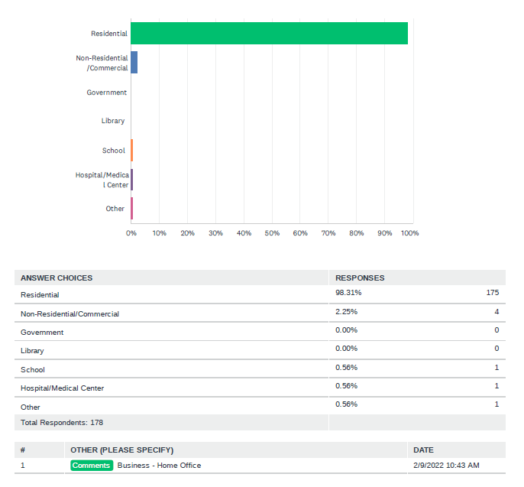

If your property is commercial, what type of commercial building?
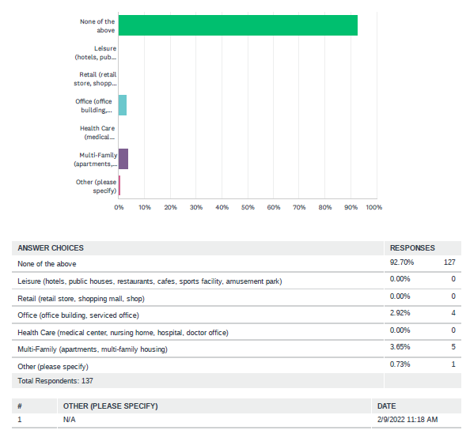

Which of the following internet access options are available at this address? (Please select all that apply)

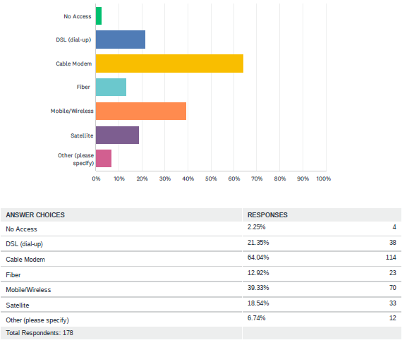
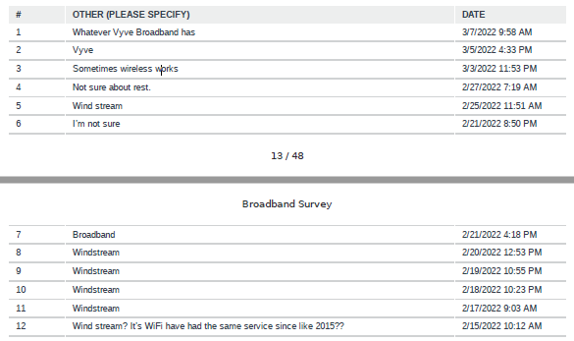
Are the internet services options at this address adequate?

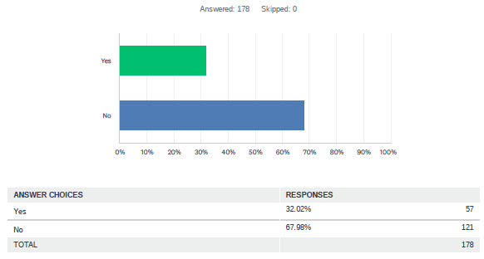

Which of the following uses would Internet service at this address before? (Check all that apply
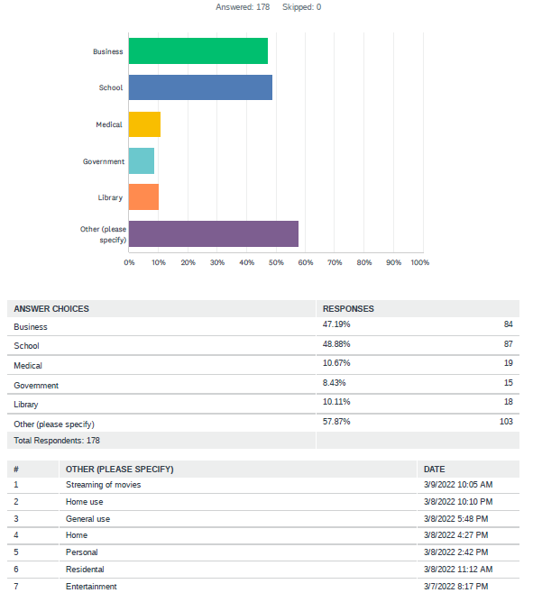
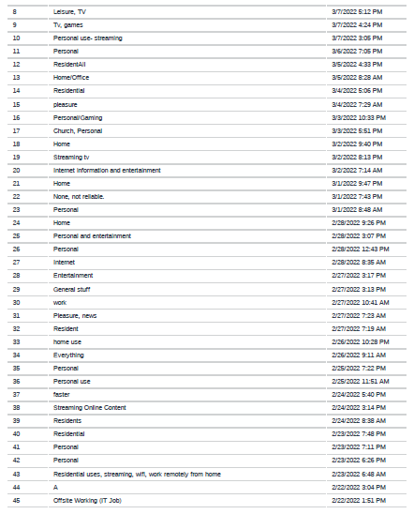
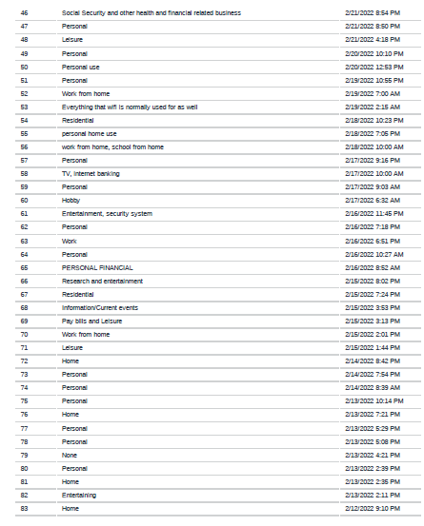
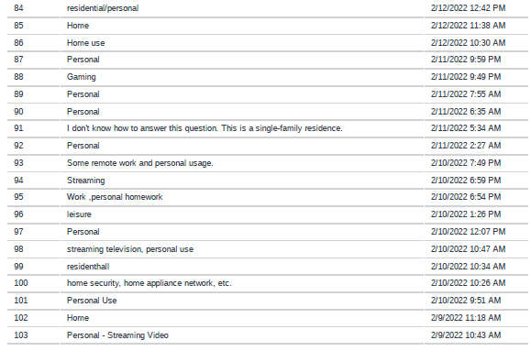

Is your Internet service consistently reliable for the address you are reporting on?
Answered: 178
Skipped: 0

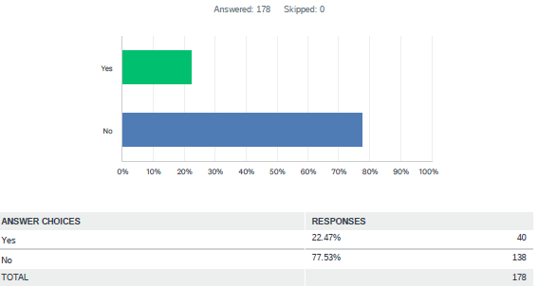

Are the Internet speeds sufficient to meet your needs for the address you are reporting on?
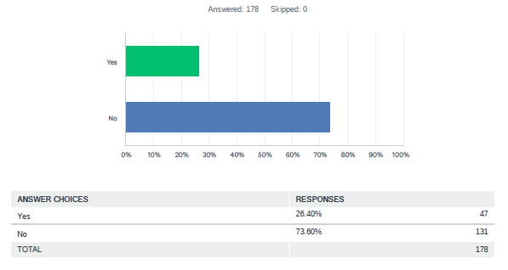

Does the Internet service cost seem appropriate for the service speed and reliability received at the location you are reporting on?
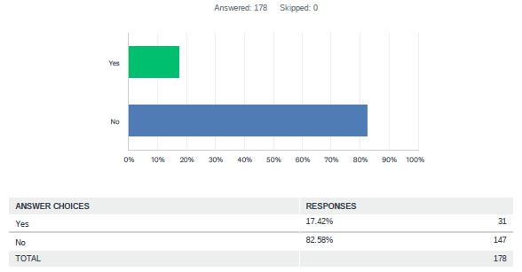
Please share any other comments you have below:
